**Movie Landing Page Website Design**

|  |  |
| --- | --- |
| **Name** | **: VUCHA VENKATA SUDHIR** |
| **Email** | **: sudhirvucha@gmail.com** |
| **Roll NO** | **: 20HU1A0454** |

**College Name : Chebrolu engineering college**

**Phone number: 8374914819**

**source code:**

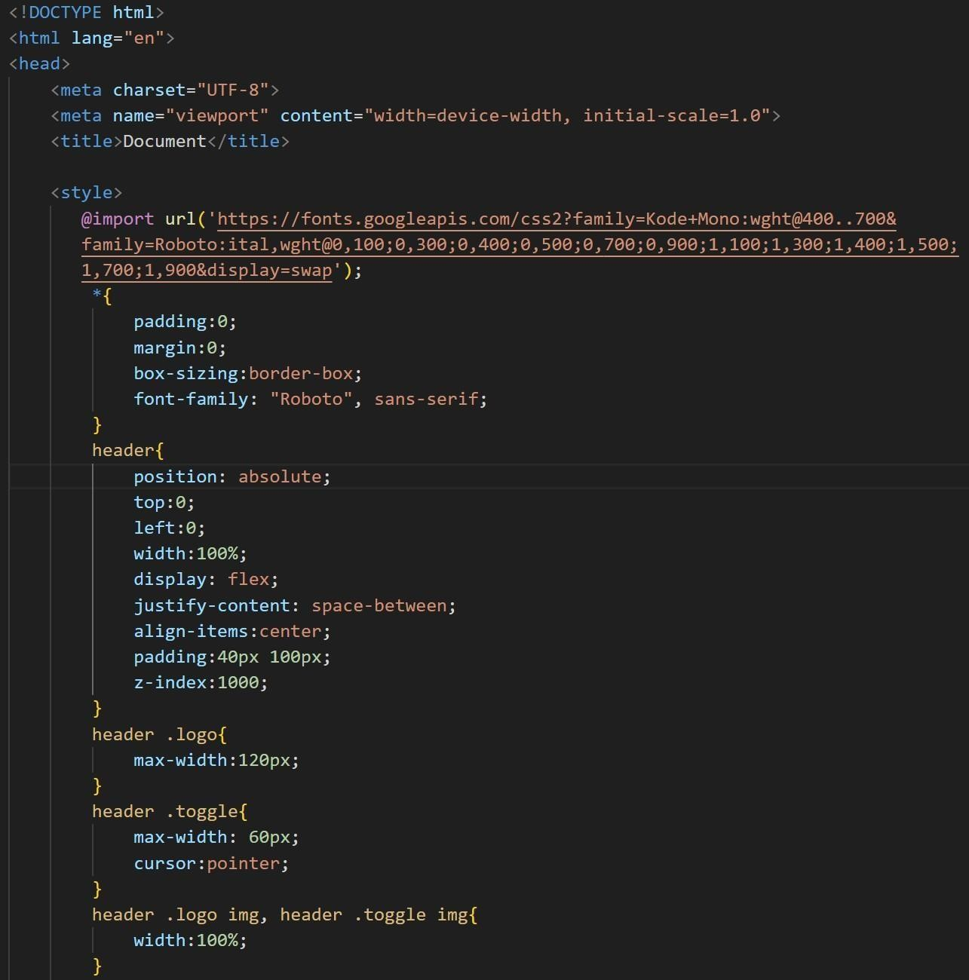

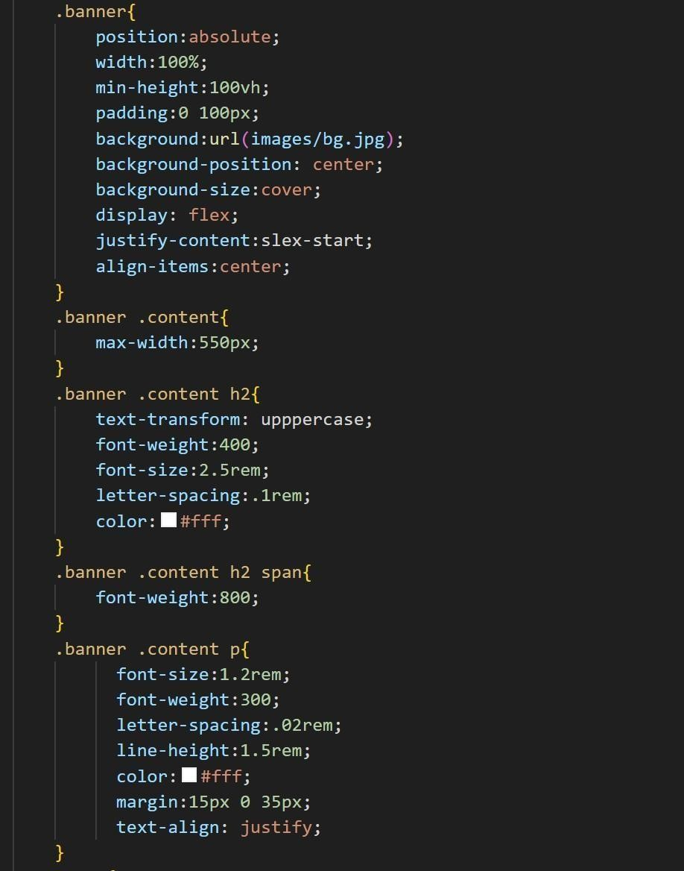

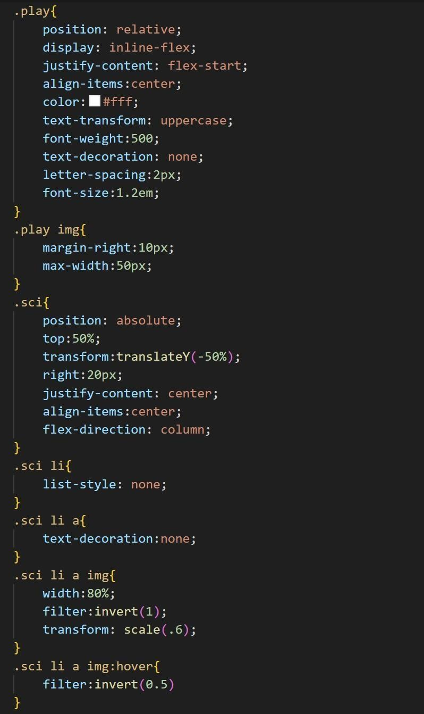

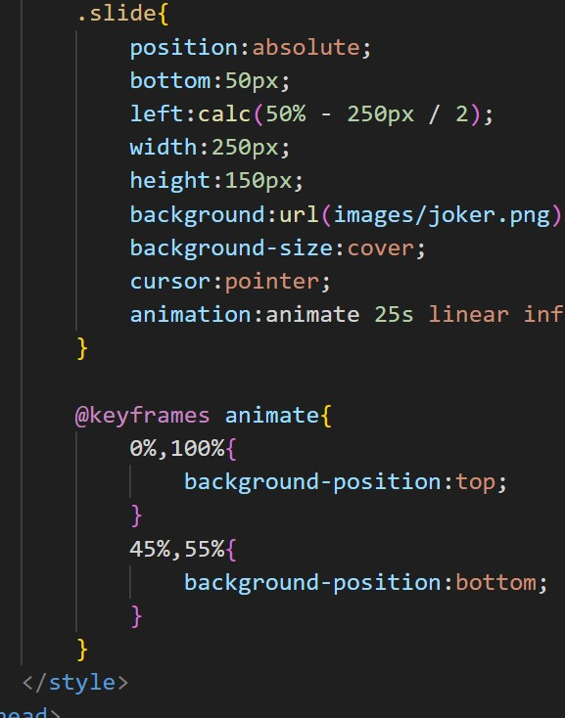

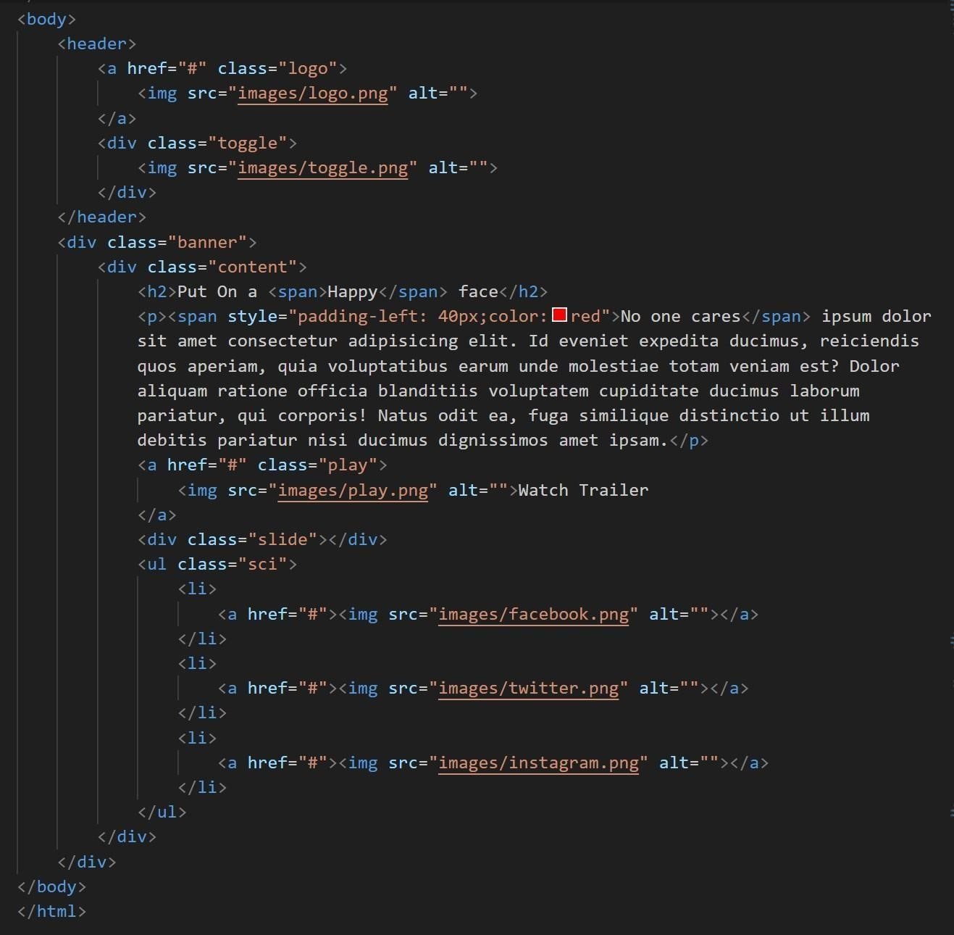

**flnal output :**

